## 1. Your abstract should be one paragraph long

## 2. The abstract should have a title and the names of the group members.

## 3. In your abstract describe what problem you may deal with and how the data may address the problem. Layout a brief plan. Note that this may change as you progress through your project work.

## · **File Types** pdf

## 

## 

## Analysis of Voter Turnout in Douglas County, NE

## 

## A.J. Guevara

## Anh Hoang

## James Geiger

## Pratik Kandel

## Ramesh Danuwar

## Yuxuan Chen

## 

## **Abstract**

## 

## Historically, the trend in voter turnout for elections in the United States is based on the expansion of voting rights. Voter turnout becomes gradually larger over the years when the restrictions are lifted to all citizens who are eighteen years or older. In this research, the analysis of voter turnout will be focused on Douglas County, Nebraska. Using public data from the Douglas County Election Commission, we will create data products to investigate how voter turnout may differ between presidential and non-presidential election years, and whether We will also compare primary and general elections, analyze how voter registration has changed since 1998, and how demographics have changed which could affect voter registration. Ultimately, we will use our data products to predict how past voter turnout could affect voter turnout in the 2020 general election.

## 

## Analysis of Voter Turnout in Douglas County, NE

### Source of Data

General/Primary elections in Douglas County from 1998 - 2020

<https://votedouglascounty.com/voter_turnout.aspx>

**Note:** Nebraska’s second district encompasses all of Douglas County, but also includes some of Sarpy county. This analysis should likely only include Douglas County, because even though the two counties share the second district, each county has its own election commission that reports data differently. ([See how Sarpy County reports their data.](https://www.sarpy.com/offices/election-commission/election-results)) This would technically limit our ability to analyze the *outcome* of elections, unless someone could find a sufficiently specific dataset that includes local boundaries (I’ve not been able to find one).

Yes, very stupid. Makes me furious. But such is the US election system.



### Data Analysis Ideas

1. How does turnout differ between presidential/non-presidential election years?
2. How does turnout differ between primary and general elections?
3. How has voter registration changed in Douglas County by voting ward since 1998?
4. Can past voter turnout predict voter turnout in this coming presidential election?
5. How have demographics in Douglas County changed since 1998? Does this map onto changes in voter registration?
6. Has there been any [gerrymandering](https://en.wikipedia.org/wiki/Gerrymandering)? By who? When?
7. How is voter turnout affected by race?
8. Can we predict “voter fraud” in the 2020 race (i.e. [Mr. Trump’s claims](https://www.cnn.com/2020/04/10/politics/fact-check-trump-lying-voter-fraud/index.html))? Or maybe see if it happened in the 2016 race?

### Quick Looks

From the 2020 primary election:

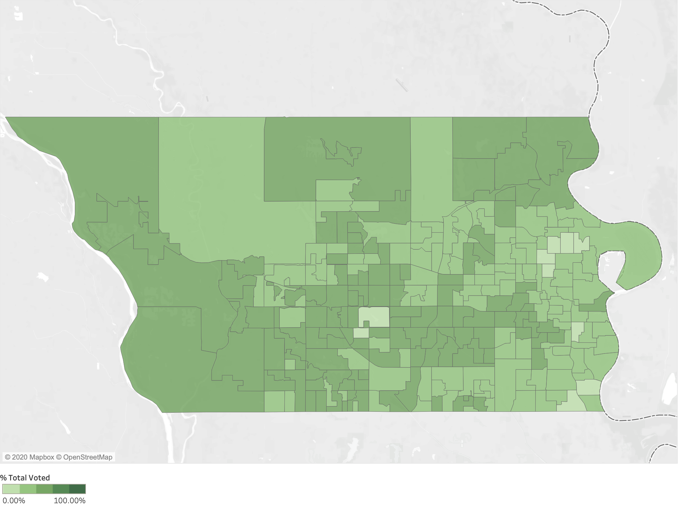

### Abstract